The Knight Times
North Cedar Community School District
Superintendent Dohmen's Message

February 2021 Issue

School Choice discussions are heating up at the statehouse. I’m an educator, not a politician; but every year I pay close attention to bills at the statehouse that impact our schools. Partly because I am an educator, but also because I am a father. As a North Cedar graduate, and now a parent of four children going to North Cedar CSD, I have always been proud and grateful of the great public education my children and I have received. I have always thought that public schools are our nation’s equalizer. Public schools create and foster our children’s dreams and aspirations. They create our future farmers, doctors, poets, the list goes on and is endless with possibilities. Also, I know public schools are our nation’s equalizer because of the accountability schools are required to meet the needs of all students.

INSIDE THIS ISSUE
Superintendent's Message...1
Message from Principal Horman..2
Message from Principal Bendixen...3
Superintendent Dohmen's Message Continued...4
Board Meeting Highlights...4
Feb. Activities Calendar...5
Below is part of an article on SF 159 that I think all parents that have children in public schools should read. I choose this section because I know that this could have a negative impact on small, rural Iowa schools. Also, I want our community to know what is being discussed at our Capitol, because it could affect your children, grandchildren, or neighborhood child that mows your lawn. I have never seen an education bill move this fast through committees and to the state floor. Not all of SF 159 is
Knight Contact Information
Mark Dohmen Superintendent mdohmen@north- cedarstu.org
(563) 942-3358

Mary Bendixen Jr/Sr High Principal mbendixen@north- cedarstu.org
(563) 452-3179

Jennifer Horman Elementary Principal jhorman@north- cedarstu.org (563)
432-6933 or (563)941-5383
detrimental to public education, but as parents, grandparents, and Iowans, I want you to know that this does impact you.
Few people know that I carry an Iowa quarter in my right pocket. Often, when I have a bad day or a conversation with a teacher or parent that doesn’t go the way I would like, I take the Iowa quarter out of my pocket and see that one room schoolhouse and know Iowans chose that to be on our state quarter. That makes the day better immediately. I love our public school; it is the promise of Iowa. Please consider talking to your legislators about the importance of Iowa public schools, or better yet, share how they made you who you are today.

Complete Call to Action from RSAI can be found at https://www.rsaia.org/2021-legislative- session.html

Here’s what you need to know:
SF 159 Governor’s Education Plan. This bill has many provisions that RSAI opposes that are not for Iowa. To dig deeply into the details, see a detailed section by section description of the bill. This bill was approved by the Senate Education Committee on Monday, Jan. 25, 8-7, with Republican Sens. Cournoyer and Sweeney voting no with the Democrats. The bill is scheduled for the Senate Ways and Means Committee consideration as a Committee of the Whole, a procedure to bypass a separate subcommittee meeting at 11:30 on Tuesday, Jan. 26, in the Senate Chamber. View the committee at this link: https://www.legis.iowa.gov/dashboard?view=videoLive&chamber=S

...Continued on page 4

Message from Principal Horman
January has given us lots of snow to play with at recess. Here is a picture of a couple students enjoying all our snow. I am also sharing pictures and brief details of events from the elementary buildings this past month.
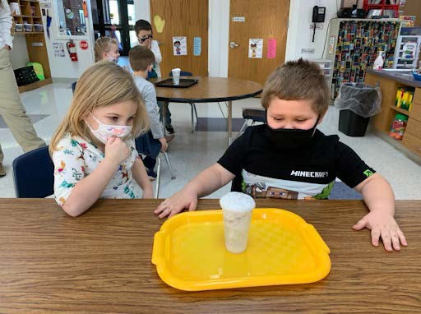
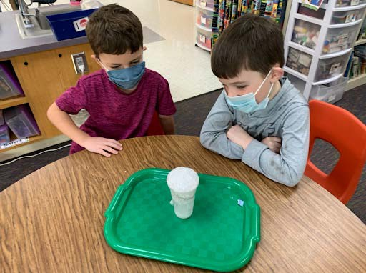
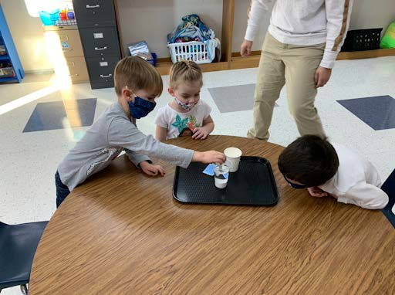
With all the snow falling outside, the preschoolers in Mrs. Jensen’s class tried making a snow storm inside. They added baby oil, water and silver glitter to a cup. The magic happened when the preschoolers added pieces of Alka Seltzer to the mixture. It was “snow” much fun!
Mrs. Weber’s first grade class wrote their personal narratives using the signal words first, next, then and last. They also learned about Martin Luther King Jr. and wrote our own “I have a dream“ papers.
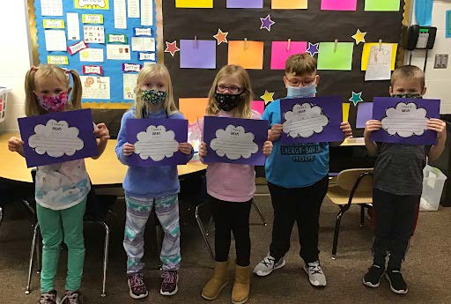
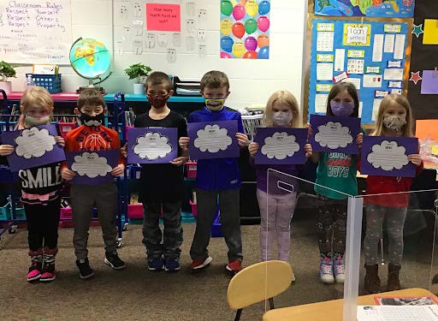
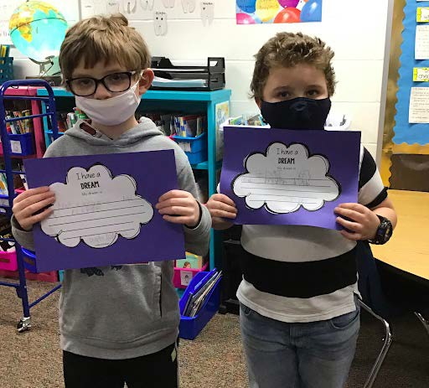
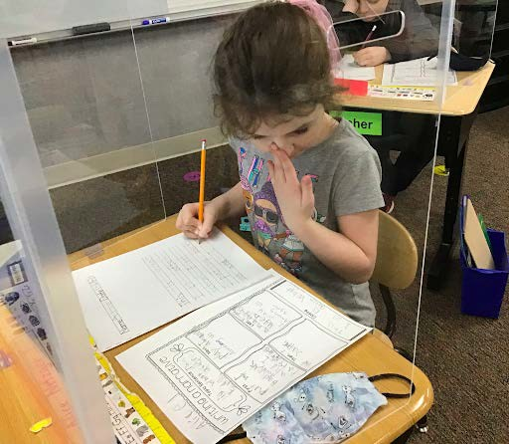
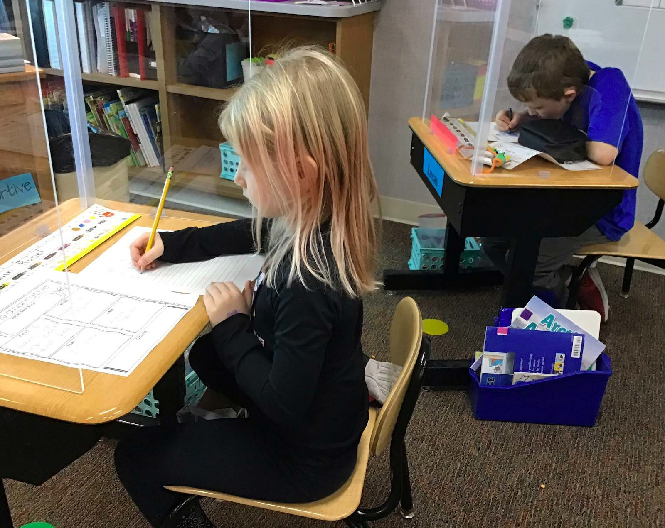

Mrs. Hendrickson’s second grade earned a class reward and voted for pajama day. They enjoyed having a cozy Friday!
Ms. Harr’s third grade class is currently working on the multiplication and division facts in math. Next week, they will be working with fractions. The reading skill they are working on is fact and opinion, including learning about persuasive letters. They continue to learn how to write in cursive. In social studies, they are studying government which includes the Declaration of Independence, the Constitution, and the Bill of Rights. For their read aloud, they read the book Old Yeller and then watched the movie.

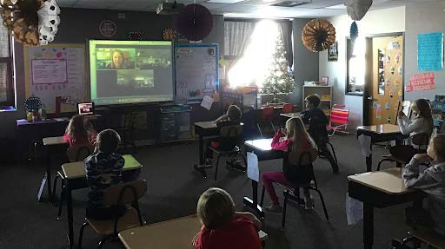
Mrs. Jackson’s third grade class took a virtual trip to a farm in New Providence, the Brown family farm. A farrow to finish pig operation. They also read a book with 4-H & Youth Outreach Educator, Teresa Bohlman, played a T/F game and received a bag with munchies in it that simulated swine feed ration. They were left with a bag of goodies that contained some fun reading and an activity packet.

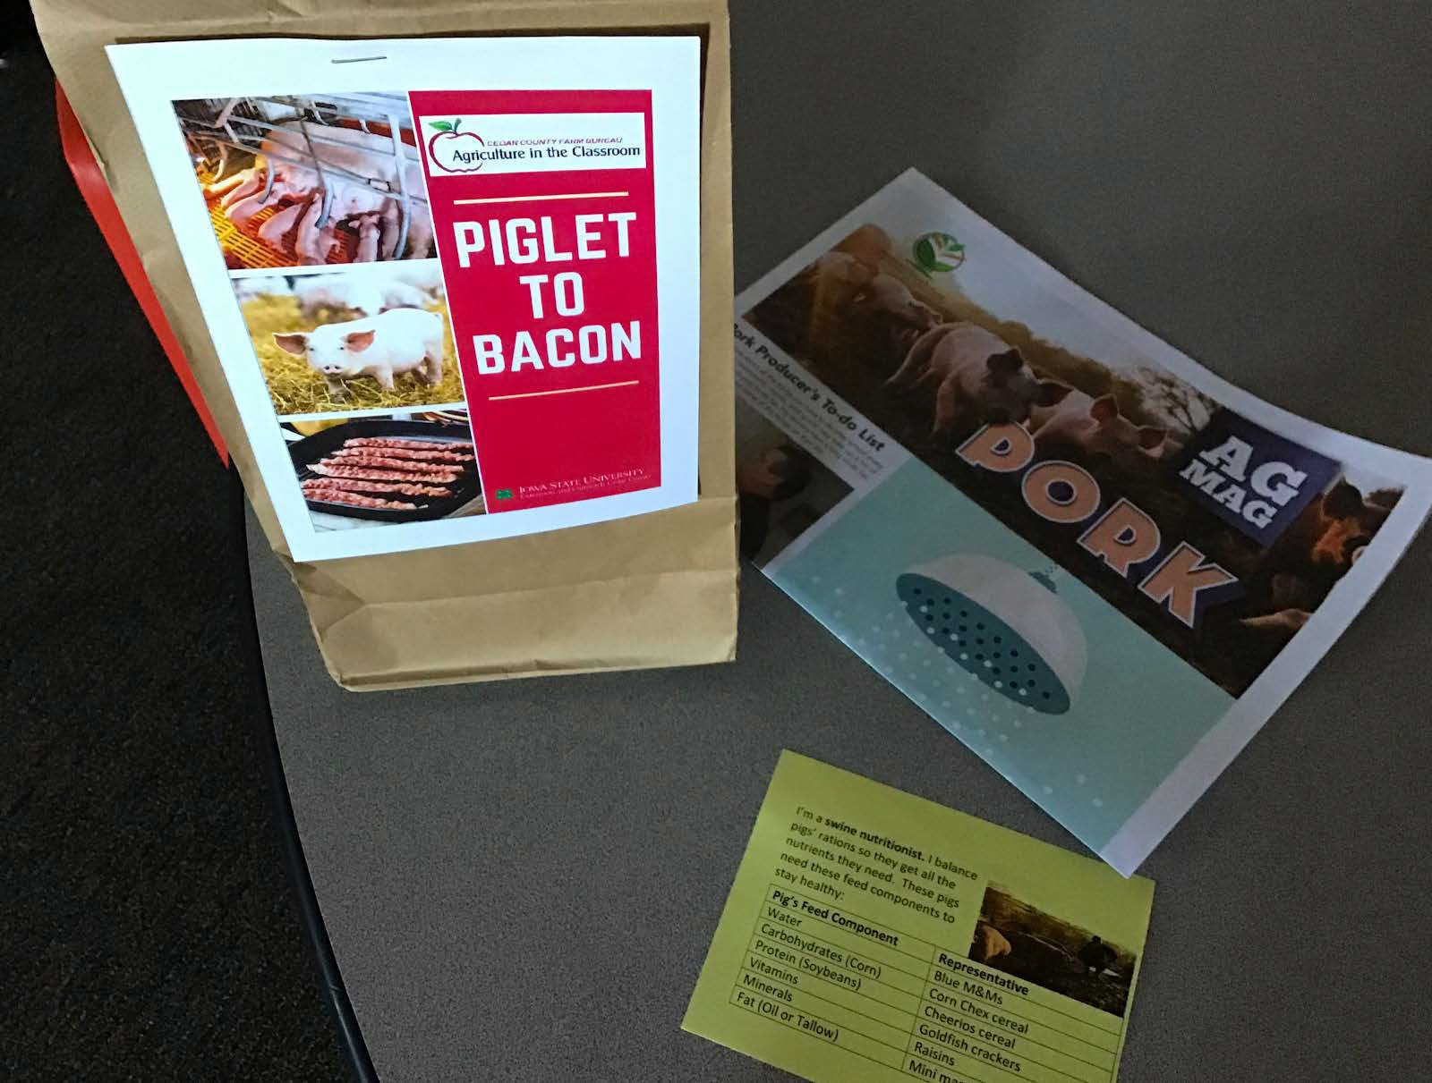
Mrs. Farrington’s fourth grade class just finished writing and sharing their informational reports they've been working on. This class has a lot of interest in farming and animals! It was fun listening to them share the new things they learned about their topic. Speaking of farming, the class had a zoom lesson this month with Mrs. Bohlman, 4-H & Youth Outreach Educator, where they learned all about pigs! They are also wrapping up double digit multiplication and moving onto division. In reading, they've been reading trickster tales and performed two reader's theater plays involving witty characters, who were a lot of fun to perform. They just finished their science unit on rocks, and will be switching over to social studies once again, to work on more states and capitals in the United States.

Mrs. Haye’s students have been learning all month about penguins. They have explored where they live, what they eat, and other interesting facts. Yesterday, they made a penguin snack!! The kids loved it!! Next, they will start learning about our communities and the people who work in them!
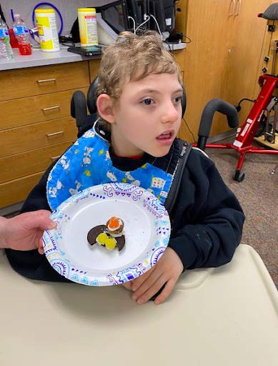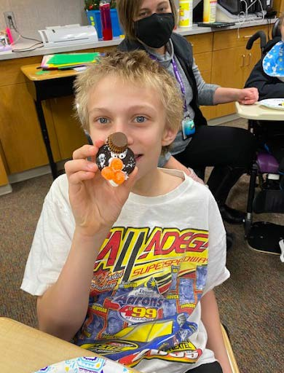

Message from Principal Bendixen
We are halfway through the 20-21 school year, and I’m feeling pretty good about how things have been going! In August, I was concerned that we would be open for just a few weeks and then would have to switch to virtual learning. Thanks to the efforts of students and staff to follow the safety guidelines we put into place, we have been able to remain on site for the entire first semester. I am pleasantly surprised and proud of what we have accomplished. Very soon, school staff will be eligible to receive the COVID vaccine which makes me hopeful that things will return to “normal” in the near future.

Academics
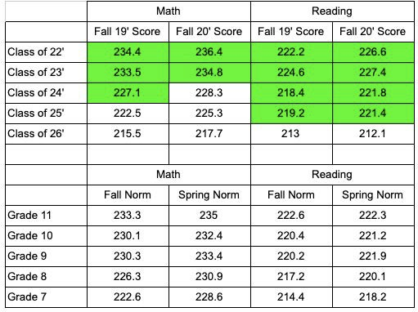
The table below summarizes our most recent MAP data, which includes Fall of 2019 and Fall of 2020. We did not test in Spring 2020 due to school closure. The top half of the table shows North Cedar students’ scores. The bottom half shows the norms for each test/grade. Thanks to Jay Fetzer, Instructional Coach, for organizing this data and summarizing the results with the following bullet points:
- Scores highlighted in green indicate the class exceeded the fall norm for that test in the year indicated.
- Grades 8 through 11 performed better on average in the fall of 2020 on both the reading and math MAP test than they did in the fall of 2019. With the extended time off from last year due to the pandemic, it might have been reasonable to expect regression instead of progression. This is a good sign!
- 7th graders showed improvement in math from the fall of 2019 to 2020 but regressed in reading slightly.
- Reading scores are especially encouraging. Grades 8 through 11 exceeded the fall norm for reading in both 2019 and 2020. Our 10th-graders this fall scored, on average, in the 65th percentile as a group.
- Math scores were strong for our sophomores and juniors. Their scores in the fall of 2020 exceeded both the fall and spring norms. This was also true for their reading scores.
- 7th graders scored below the norm in both reading and math on the fall MAP tests. We will determine what support our 7th-grade students need going forward as we prepare for MAP and ISASP testing in the spring.
- Our general trend in the last several years has been for our students to score reasonably well in the fall, but demonstrate little growth in the spring. Conversations regarding this trend are on-going.

Professional Development
The focus of professional development this year has been on technology to support virtual learning. Our teachers have devoted countless hours to supporting both on-site and virtual students. Here are some examples of work accomplished by our Math, ELA, and Special Education teachers during our PD time...

From Alexandria Van Trump, JH Math: My professional development time is mostly spent recording lesson videos. I pre-record the videos and put them online the day of the lesson. I provide notes, examples/solutions, as well as time for them to pause and reflect. I have also set up Google Forms for students to fill out if they ever need additional support or help with math assignments. They (or their parents) can sign up for a time to meet with me over Zoom. I have also utilized PD time to create a website to organize all of these lessons. The main reason I created the website is to have a location for students to go if they are getting lost/stuck. I can guide them to a lesson that they should review, and they can find that quickly with the use of my website. Google Classroom is great for daily work, assignment tracking, and completion. My website is just a great way to organize it all. I have also started using the program Geogebra. This is a free online program that allows me to incorporate math symbols, graphing, tables, and has elements where students can draw and links right up to Google Classroom.

From Scott Kasik, HS Math: I have been making a recording of all my lessons with examples for each class. This allows students who are virtual and those that need to revisit the examples of each day to do so in Google Classroom. Notes are also featured in GC. Requiring all assignments to be done prior to assessing sets a clear expectation and provides incentive for students to complete the work.

From Stacey Moorman, JH English: All lessons and assignments are posted on Google Classroom and are available for virtual students to complete throughout the week. All materials, notes, assignments, and assessments are digital and available to all students. No Red Ink is used to support student learning of the language standards. This program allows me to assign practice lessons that align with the learning targets we work on in class. I can also use it to assign lower-level lessons to students who are not ready for the grade-level content. During class, I try to include writing time where I am available to talk them through some of their writing and give them immediate feedback. I also use the writing process to allow them opportunities to get feedback from each other, but that has been a little more complicated to set up due to Covid-19 precautions. I do my best to make priority standards and learning targets clear to my students. I also offer them multiple opportunities to reassess and will find time to meet with students before they reassess to help them learn the necessary skills and information.

From Amy Fortin, 7-12 Special Ed: The main components I have incorporated into my math lessons are the use of multiple types of manipulatives, as well as repetition. I model most of the student work tasks (money, time, counting etc.). I also plan my lessons around student goals and the Iowa Core Essential Elements. For example, when working on finding Area with a student, we have counted tiles, taped off a part of the classroom floor and counted the tiles to figure out the area in our classroom, and we will be starting to determine Area in word problems.

Behavior
Our first semester celebration was January 29 and included games, an awards ceremony, and quarter drawings. The PBIS leadership team participated in another Tier 3 training session on January 27, with the next session scheduled for February 24.

Activities
The guidelines on events have changed once again. Governor Reynolds lifted the limit on spectators at events, but has left it up to districts to determine the maximum capacity with social distancing in their facilities. At North Cedar, we will continue to allow households to attend as a group and will provide 4 additional tickets per participant.

Superintendent Dohmen's Message
Continued from page 1
Vouchers: SF 159 (formerly SSB 1065) includes “Student First Scholarships” called education savings accounts for resident students in schools in need of comprehensive support and improvement (some urban, some rural).

Here are some talking points to use regarding vouchers:
- Use public dollars for public schools. Period. The public’s investment should be used to support public community schools which are open to all students regardless of race, religion, gender, socio-economic status and disability, not for a new entitlement program for parents who choose private education.
- Public funds require public accountability and transparency. Public schools are overseen by a publicly elected citizen governing board, are required to report academic results to the general public, have an annual public financial audit, and be transparent with all expenditures and decision-making. Private and religious schools are not held to that same public standard. Taxpayers have a right to know how their funds are being used, but are left in the dark about the use and impact of voucher funds.
- A slippery slope toward a costly and expansive voucher program: This voucher program may start small, but as we've seen in other states, once a program is established, it is easy to expand. This will pull more resources away from public schools.
- Vouchers don’t deliver improved student learning: Recent Federal Department of Education review of the DC Voucher plan after three years showed no improvement of learning for any subgroup. Funding the $10 million in High Needs schools grants originally included in Bi-partisan Education Reform Legislation in 2013 would be a good start. Considering a poverty factor in the funding formula for districts with concentrated poverty would also improve results.
- Vouchers provide no additional options for most rural school students: this Map of Private Schools in Iowa from IASBs web site shows where private schools are located and which legislative district they are in. Show your legislators that rural students will not benefit from a voucher program and public schools are their best and only choice. The National Coalition Fact-sheet on Rural Schools and Vouchers states: Vouchers don’t provide an actual choice for students living in rural areas who have little, if any, access to private schools. If students are able to use a voucher, they are generally required to endure long, costly commutes. And, vouchers are especially harmful to the public school systems serving large rural areas because the schools are forced to spread the same costs for facilities, transportation, administration, and instruction over a smaller revenue stream. Find the whole document on their website here (https://www.ncpecoalition.org/ruralvouchers#:~:text=Vouchers%20don%27t%20provide%20an,to%20endure%20long
%2C%20costly%20commutes.).

January Board Meeting Highlights
Each month the North Cedar School Board shares a few highlights of our monthly board meetings. These takeaways are messages that the board collectively feels are important for the public to know. Here are the highlights from the Jan. 18, 2021, meeting:

Elementary Reading Interventions. An individualized program of working with kindergarten students to improve recognition of upper and lower case letters and sounds showed 98% proficiency in one test category assessed in early January. Improvement as high as 63% was also observed in another test category from September to January. This success is the result of a reading intervention program that supplements traditional classroom teaching with up to 30 minutes per day of additional focused instruction for groups of students matched by skill level. The intervention time is led by elementary specials’ teachers along with reading and classroom teachers. Research shows that mastering the core foundations of reading early in a child’s education afford more success in the long term. The program was expanded to include first grade in Lowden this year and has the potential to reach other grade levels and subject matters in the future.

Secondary MAP Testing Growth. Despite the challenges the pandemic has presented to student learning, fall 2020 reading and math MAP testing at the junior and senior high level shows students performed better, on average, in the fall of 2020 than they did in the fall of 2019. Students in grades 8 through 11 exceeded the fall norm for reading in both 2019 and 2020. Math scores were also strong. While many classes showed growth or little regression, there is still room for improvement and the district continues to utilize MAP testing and other assessment data to adapt learning methods to best prepare our students.

Significant Interest Savings. The district refinanced $3.1 million in School Infrastructure Sales, Services and Use Tax Revenue Refunding Bonds. The bond sale on existing construction debt will save district patrons $302,000 in interest payments over the next nine years. The lowest proposal came from Bridge Community Bank, Mechanicsville, in cooperation with Liberty Trust & Savings Bank, Durant. Their average interest rate of 0.79% resulted in an additional interest savings of approximately $115,000 above the next closest proposal. We thank these local banks for their partnership.
To view the full agenda and attachments of North Cedar School Board meetings, click the Online Board App button at https://north-cedarstu.org/Board_of_Education. Meeting minutes are also posted online following each meeting.

North Cedar Lunch & Activities Calendar
February 2021
Calendar is subject to change.
Mon., Feb. 1: Lunch: Elem.: Pizza or Orange Chicken; Jr/Sr High: Pizza Mon., Feb. 15: No School

4:15pm Jr. High Boys Basketball @ Monticello MS 5:30pm JV Boys Basketball @ Calamus Wheatland 6:30pm Varsity Girls Basketball @ Calamus Wheatland 7:15pm JV Girls Basketball @ Calamus Wheatland 7:30pm Varsity Boys Basketball @ Calamus Wheatland

Tues., Feb. 2: Lunch: Chicken Nuggets
4pm JV Girls Basketball vs Anamosa @ Jr/Sr High
4pm Fresh/Soph Boys Basketball vs Anamosa @ Stanwood 5:15pm JV Boys Basketball vs Anamosa @ Jr/Sr High 6:30pm Varsity Girls Basketball vs Anamosa @ Jr/Sr High 8pm Varsity Boys Basketball vs Anamosa @ Jr/Sr High

Wed., Feb. 3: Lunch: Cavatelli 1pm Early Dismissal

Thurs., Feb. 4: Lunch: Elem.: Chicken Noodle or Chili; Jr/Sr High: Broccoli Cheese or Chicken Noodle Soup
4:15pm Jr. High Boys Basketball vs Camanche @ Stanwood Fri., Feb. 5: Lunch: Hamburger
Sat., Feb. 6:
Meistersinger Honor Band @ Wartburg College 12pm Varsity Wrestling Sectionals @ Lisbon HS 3:15pm JV Girls Basketball @ Camanche
4pm JV Boys Basketball @ Camanche 5:15pm Varsity Girls Basketball @ Camanche 6:30pm Varsity Boys Basketball @ Camanche

Sun., Feb. 7:
Meistersinger Honor Band @ Wartburg College

Mon., Feb. 8: Lunch: Elem.: BBQ Rib; Jr/Sr High: BBQ Rib or Chicken Club
4:15pm Jr. High Boys Basketball @ Cascade HS (8th Grade will play first)

Tues., Feb. 9: Lunch: Elem.: Breaded Pork Chop; Jr/Sr High: Salisbury Steak
4pm JV Girls Basketball vs Bellevue @ Jr/Sr High 5:15pm JV Boys Basketball vs Bellevue @ Jr/Sr High 6pm Varsity Girls Basketball vs Bellevue @ Jr/Sr High 7:30pm Varsity Boys Basketball vs Bellevue @ Jr/Sr High

Wed., Feb. 10: Lunch: Crispito 1pm Early Dismissal

Thurs., Feb. 11: Lunch: Elem.: Lasagna; Jr/Sr High: Tater Tot Casserole
4:15pm Jr. High Boys Basketball @ Anamosa MS Fri., Feb. 12: Lunch: Chicken Patty
Sat., Feb. 13: 12pm Varsity Wrestling Districts @ Wapello HS
4:15pm Jr. High Boys Basketball @ Maquoketa HS Tues., Feb. 16: Lunch: Walking Tacos
Wed., Feb. 17: Lunch: Elem.: French Toast Sticks; Jr/Sr High: French Bread Pizza
1pm Early Dismissal

Thurs., Feb. 18: Lunch: Elem.: Popcorn Chicken; Jr/Sr High: Baked Potato Bar
9am Varsity State Wrestling @ Wells Fargo Arena
4:15pm Jr. High Boys Basketball vs Northeast @ Stanwood

Fri., Feb. 19: Lunch: Elem.: Corn Dog or Breaded Shrimp Poppers; Jr/Sr High: Corn Dog or Cheddarwurst
9am Varsity State Wrestling @ Wells Fargo Arena 2:30pm Varsity State Wrestling @ Wells Fargo Arena

Sat., Feb. 20:
6pm Varsity State Wrestling @ Wells Fargo Arena 10pm Varsity State Wrestling @ Wells Fargo Arena

Mon., Feb. 22: Lunch: Elem.: Grilled Chicken Breast; Jr/Sr High: Orange Chicken
4:15pm Jr. High Boys Basketball vs Bellevue @ Stanwood Tues., Feb. 23: Lunch: Chicken Fajitas
Wed., Feb. 24: Lunch: Spaghetti 1pm Early Dismissal

Thurs., Feb. 25: Lunch: Chicken Drumstick Coe Jazz Festival
4:15pm Jr. High Boys Basketball vs Monticello @ Stanwood

Fri., Feb. 26: Lunch: Hamburger or Fish Coe Jazz Festival

Sat., Feb. 27: Coe Jazz Festival

The mission of North Cedar Community School District, in partnership with its community and staff, is to ensure a safe and caring environment for each student, providing the essential knowledge, values, skills, and attitudes to create lifelong learners who are responsible, contributing, and productive citizens in a changing and increasingly diverse world.
North Cedar Community School District
102 East North St.
P.O. Box 247
Stanwood, IA 52337
Postal Customer

Everything we do at NCCSD is for our students, and we encourage them all to take part in the enrichment and extracurricular opportunities for which they are eligible.
  - Athletics for junior high school and senior high school students
  - Fine arts activities for 5th through 12th graders
  - Extracurricular clubs and organizations for junior high and senior high school students
  - Counseling services for all grades

An active, supportive community strengthens NCCSD. Parents and patrons who elect to get involved and support our students and their activities aid the district.
  - Athletics Boosters bolster our student athletes and the athletics programs
  - Encore Club supports our fine arts programs
  - Knights Community Organization fosters the relationships between parent, student, staff, and community
  - North Cedar Education Foundation provides financial support to help broaden the district’s education opportunities

